1. **15 TYPES OF CHARTS AND WHEN THEY ARE USED:**

* **Column Chart**

A column chart is used to show a comparison among different items, or it can show a comparison of items over time. You could use this format to see the revenue per landing page or customers by close date.

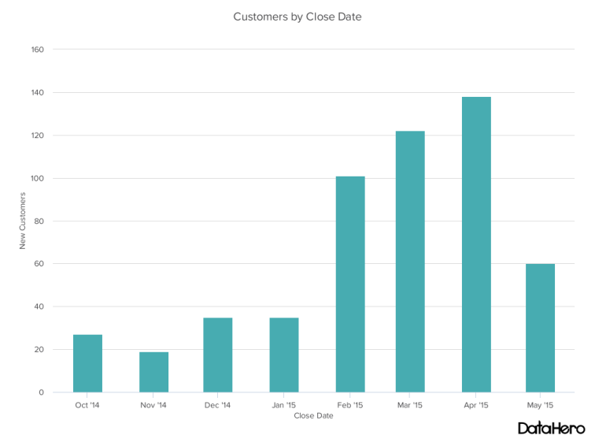

* **Bar Graph**

A bar graph, basically a horizontal column chart, should be used to avoid clutter when one data label is long or if you have more than 10 items to compare. This type of visualization can also be used to display negative numbers.

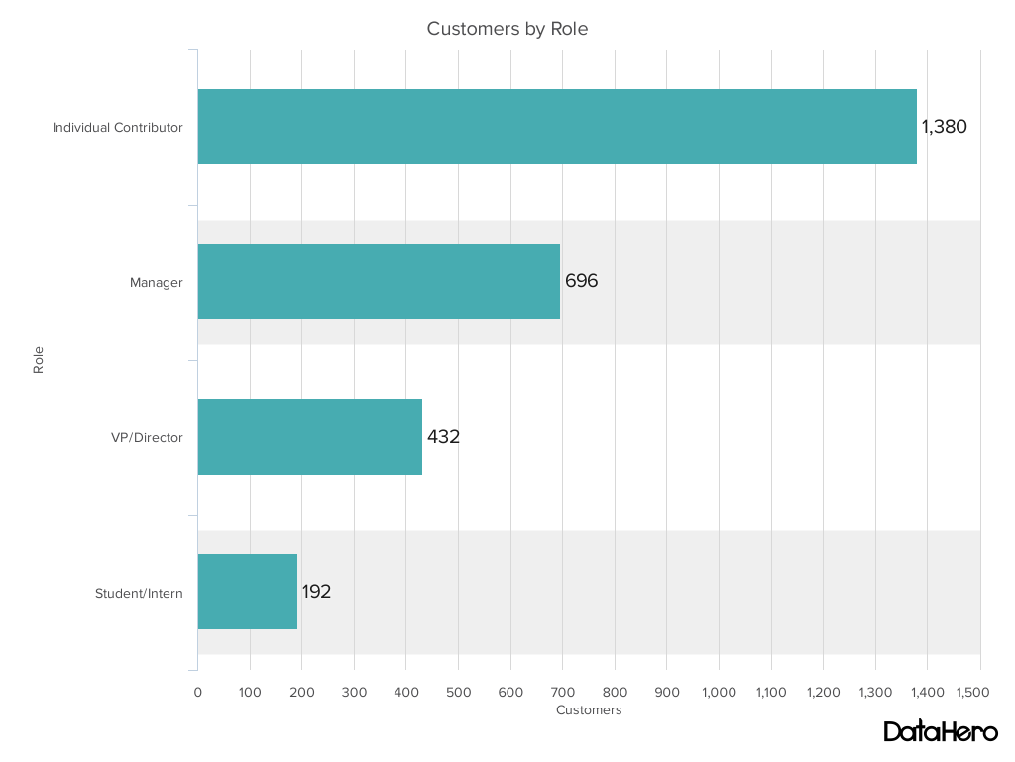

* **Line Graph**

A line graph reveals trends or progress over time and can be used to show many different categories of data. You should use it when you chart a continuous data set.

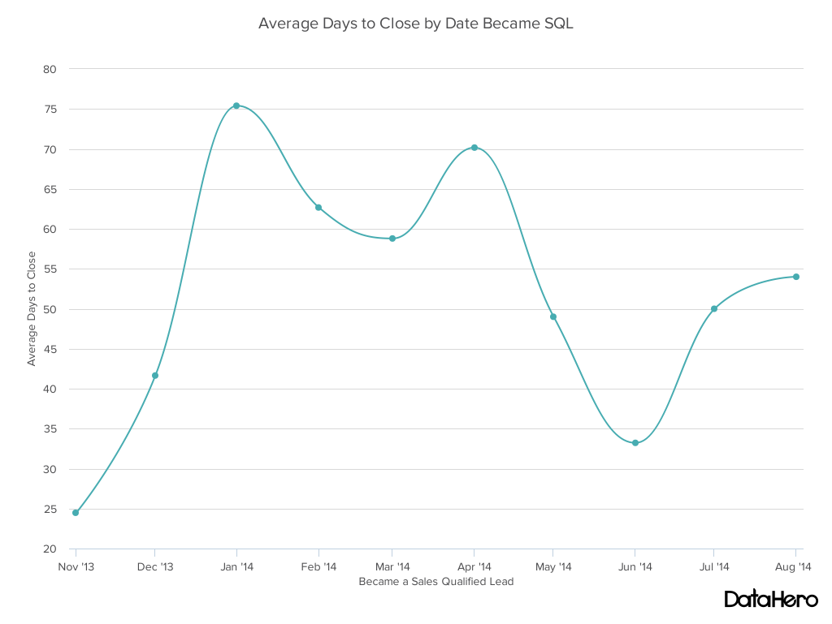

* **Dual Axis Chart**

A dual axis chart allows you to plot data using two y-axes and a shared x-axis. It's used with three data sets, one of which is based on a continuous set of data and another which is better suited to being grouped by category. This should be used to visualize a correlation or the lack thereof between these three data sets.

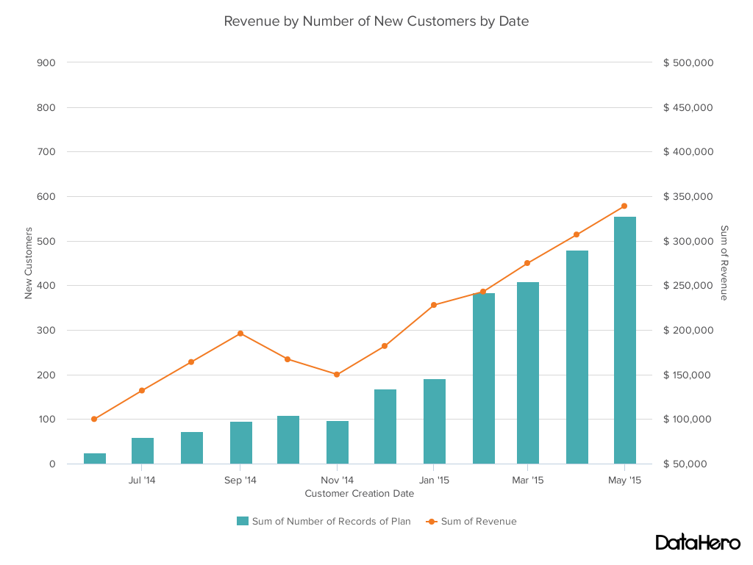

* **Area Chart**

An area chart is basically a line chart, but the space between the x-axis and the line is filled with a color or pattern. It is useful for showing part-to-whole relations, such as showing individual sales reps' contribution to total sales for a year. It helps you analyze both overall and individual trend information.

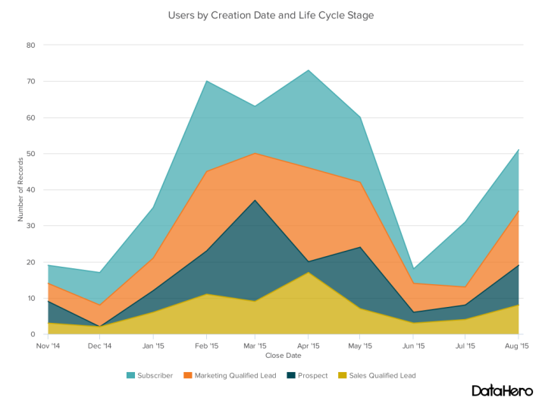

* **Stacked Bar Chart**

This should be used to compare many different items and show the composition of each item being compared.

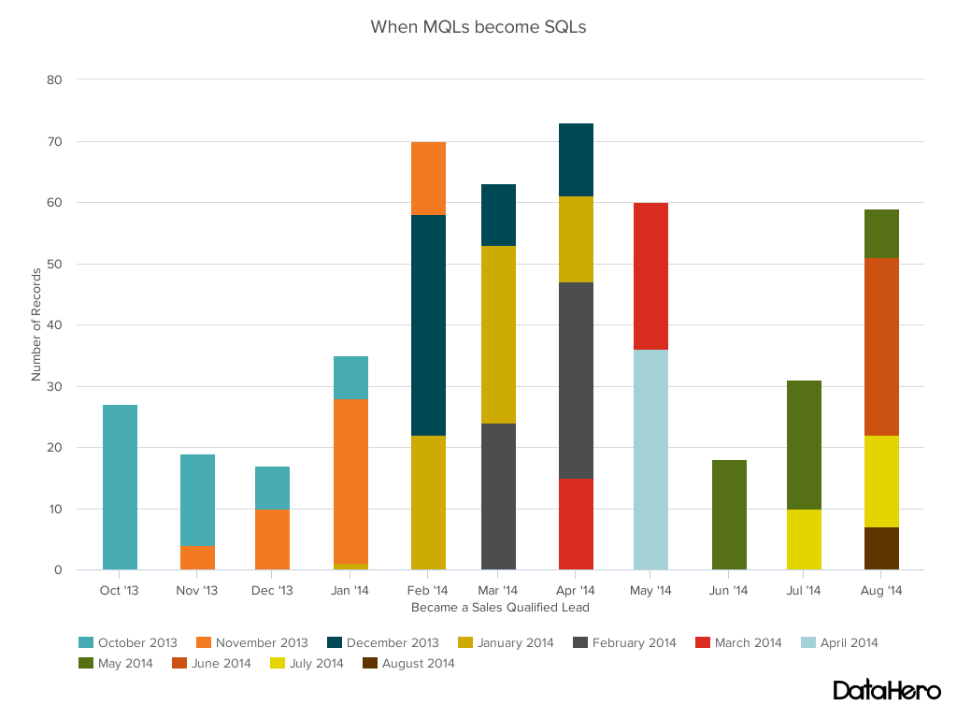

* **Mekko Chart**

Also known as a marimekko chart, this type of graph can compare values, measure each one's composition, and show how your data is distributed across each one. It is similar to a stacked bar, except the mekko's x-axis is used to capture another dimension of your values -- rather than time progression, like column charts often do. In the graphic below, the x-axis compares each city to one another.

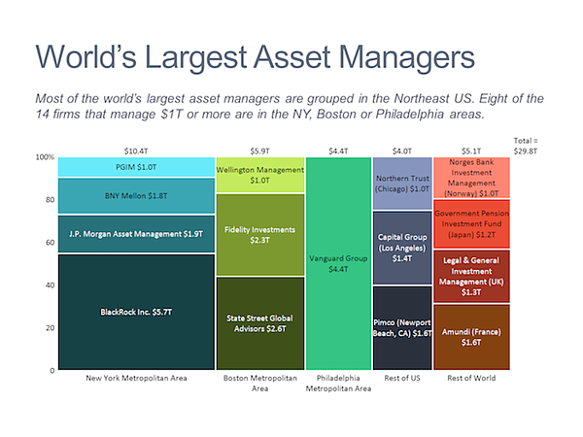

* **Pie Chart**

A pie chart shows a static number and how categories represent part of a whole -- the composition of something. A pie chart represents numbers in percentages, and the total sum of all segments needs to equal 100%.

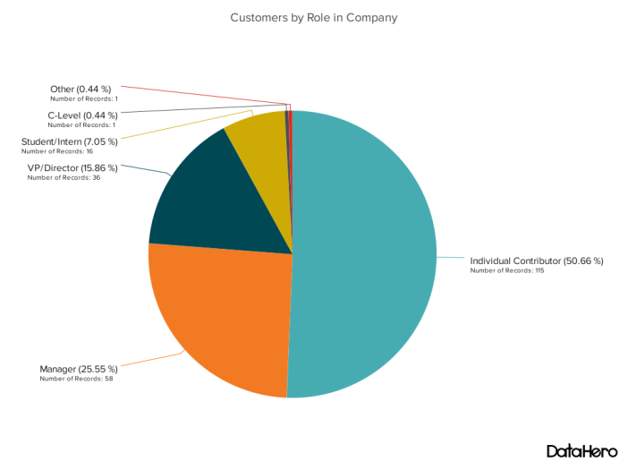

* **Scatter Plot Chart**

A scatter plot or scattergram chart will show the relationship between two different variables or it can reveal the distribution trends. It should be used when there are many different data points, and you want to highlight similarities in the data set. This is useful when looking for outliers or for understanding the distribution of your data.

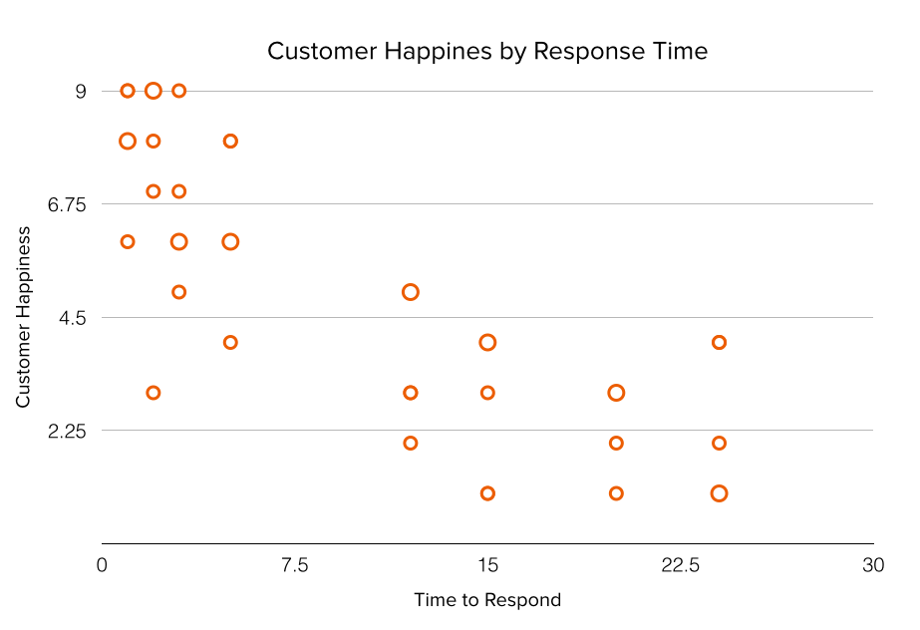

* **Bubble Chart**

A bubble chart is similar to a scatter plot in that it can show distribution or relationship. There is a third data set, which is indicated by the size of the bubble or circle.

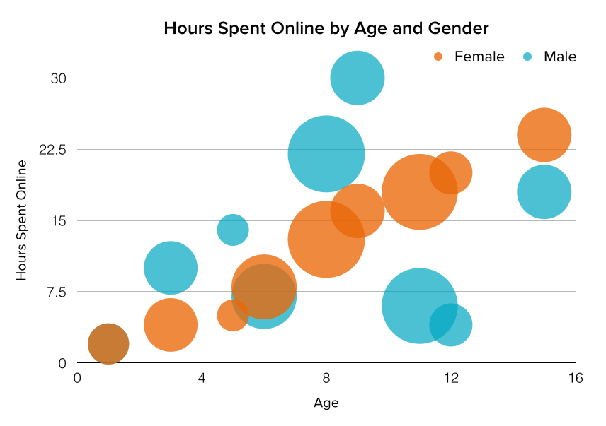

* **Waterfall Chart**

A waterfall chart should be used to show how an initial value is affected by intermediate values -- either positive or negative -- and resulted in a final value. This should be used to reveal the composition of a number. An example of this would be to showcase how overall company revenue is influenced by different departments and leads to a specific profit number.

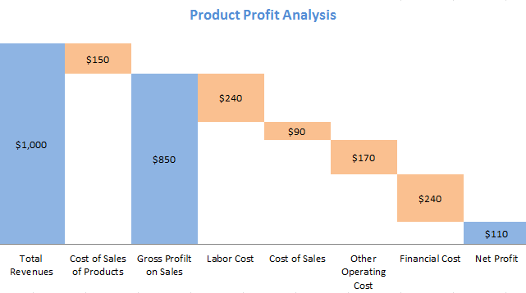

* **Funnel Chart**

A funnel chart shows a series of steps and the completion rate for each step. This can be used to track the sales process or the conversion rate across a series of pages or steps.

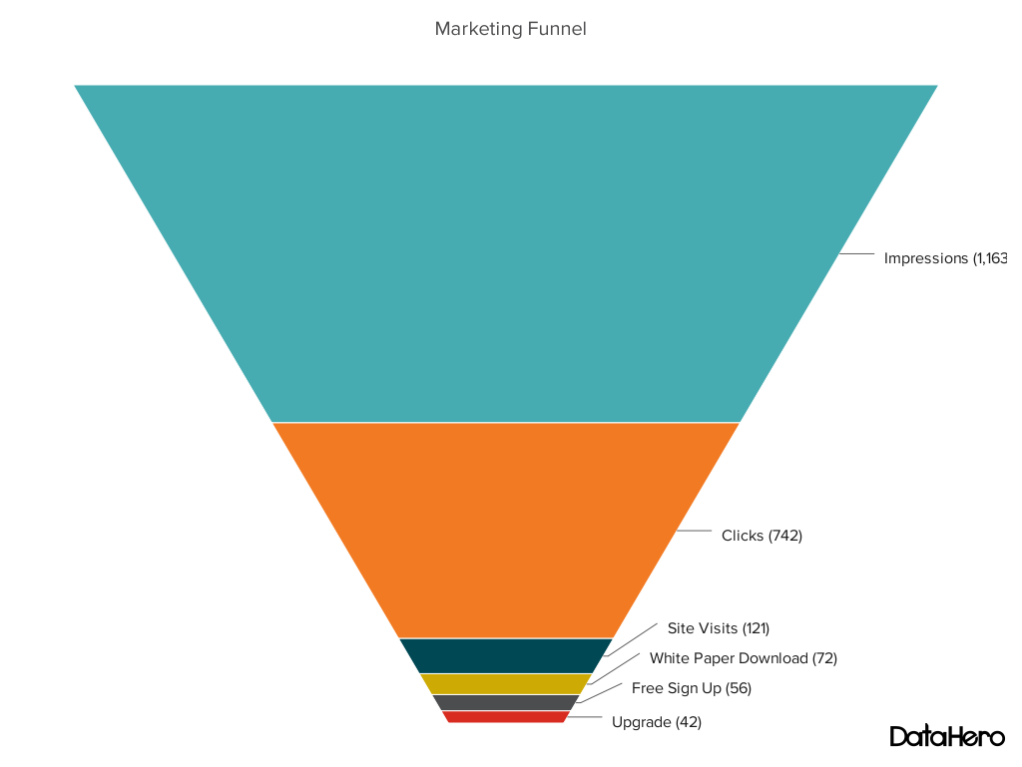

* **Bullet Graph**

A bullet graph reveals progress toward a goal, compares this to another measure, and provides context in the form of a rating or performance.

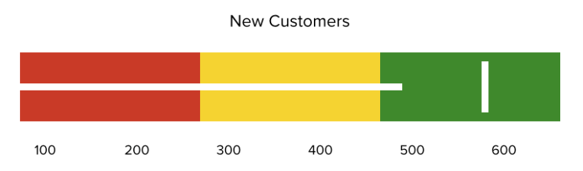

* **Heat Map:**

A heat map shows the relationship between two items and provides rating information, such as high to low or poor to excellent. The rating information is displayed using varying colors or saturation.

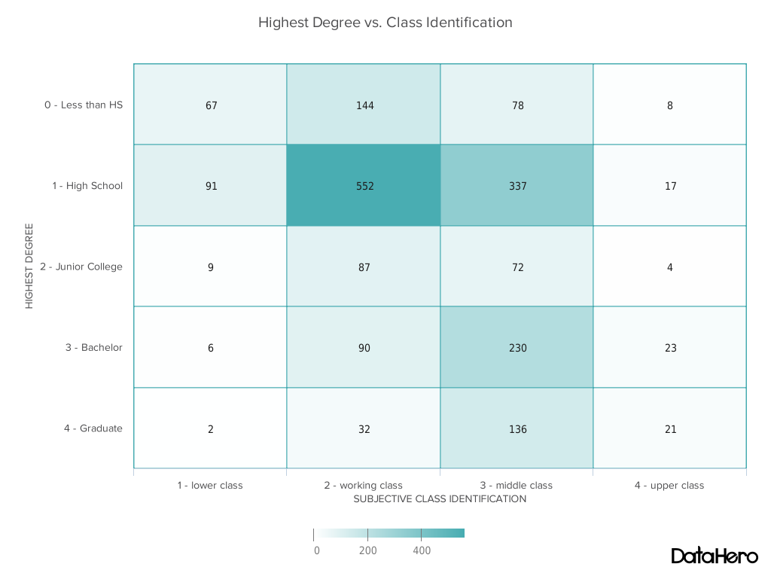

* **Combination Chart:**

A combination chart is a visualization that combines two or more chart types into a single chart. Combination charts are an ideal choice when you want to compare two categories of each individual sub-item. They are commonly used to create visualizations that show the difference between targets versus actual results.

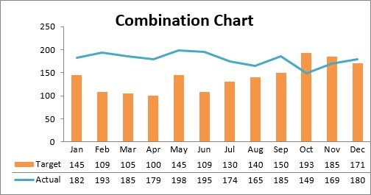

1. **TYPES OF FILES:**

* **csv - Comma Separated Values:**

****A CSV file is a comma separated values file commonly used by [spreadsheet](https://techterms.com/definition/spreadsheet" \t "techterms) programs such as Microsoft Excel or OpenOffice Calc. It contains plain text data sets separated by commas with each new line in the CSV file representing a new database row and each database row consisting of one or more fields separated by a comma. CSV files are often opened by spreadsheet programs to be organized into cells or used for transferring data between databases.

* **xls – Exce Spreadsheet**

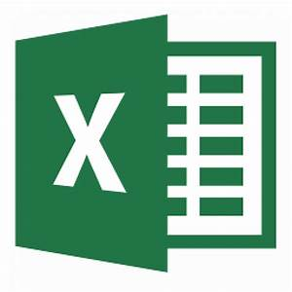

An XLS file is a [spreadsheet](https://techterms.com/definition/spreadsheet" \t "techterms) file created by Microsoft Excel or exported by another spreadsheet program, such as OpenOffice Calc or Apple Numbers. It contains one or more worksheets, which store and display data in a [table](https://techterms.com/definition/table) format. XLS files may also store mathematical functions, charts, styles, and formatting.

* **ppt – PowerPoint Presentation:**

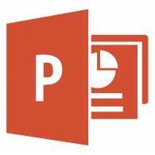

A PPT file is an editable slide show created by Microsoft PowerPoint or another presentation program, such as OpenOffice Impress or Apple Keynote. It may include formatted text, bullet points, images, movies, sound effects, and music. PPT files are commonly built from one of many templates included with the PowerPoint software, but may also be created from scratch.

* **txt – Plain Text File:**

****A TXT file is a standard text document that contains unformatted text. It is recognized by any text editing or word processing program and can also be processed by most other software programs. TXT files are often created and opened using Microsoft Notepad and Apple TextEdit.